INSTRUCTIONS TO LOAD THE BASE MAP INSIDE A PROMARK2

When you upgrade a ProMark 2 , only the firmware is reloaded inside the receiver , but not the base map. Most of the receivers are shipped with North America V1.07 base map loaded. However , for client working in European area , a Europe V1.02 base map is available.

First , the client must record the Europe base map file from the FTP site. Click on the link below to access directly to the file :
ftp://ftp.ashtech.com/Land Survey/Older Products/PM2/Firmware/Base_Map/
load the file EU_102.IMG inside a temporary directory
load the MAGUP.EXE file in this same directory

Then follow the instructions below :

1- Be sure that batteries are well charged. A sudden stop of the receiver during the loading due to poor batteries will break the receiver which should be return to factory for repair.

2- Plug the receiver on its support and connect it to your PC . Turn on the receiver by pushing simultaneously the Nav/Surv and ON/OFF key

3- Screen will diplay a window withh value 00 inside it. With UP/DOWN/LEFT/RIGHT arrow key , select each digit and change the value to 98, then valid by pushing ENTER key.

4- The receiver will then display the following message :

Warning
Reseting
serial flash
will erase
all map data?
Yes No

The Yes option is default selected . Press the ENTER key

5- The receiver erase the base map and then switch off. Switch on again the receiver , the following message appears on the screen :

RECEIVER
ACTUALLY
WITHOUT BASE MAP
RELOAD

MAP

6- Run MAGUP.EXE
UPLOAD window open. Answer NO

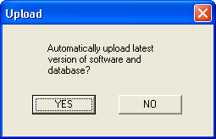

7- Select EXPERT on the menu list. EXPERT SETUP window open. Select the following parameters.

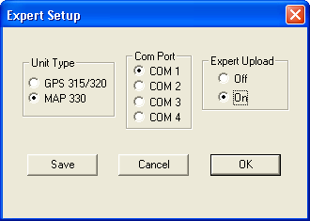
Nota : the COM port should correspond to your PC COM port.
Select OK

8- Open the menu FILE and select DATA BASE FILE. In the OPEN window, select the EU_102.IMG file (corresponding to the V1.02 european base map).

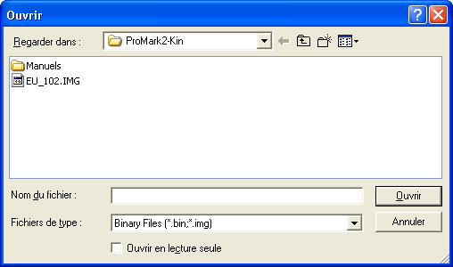
Click on OPEN.

8- Select the UPLOAD menu , click OK :

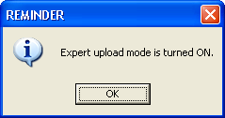

9- In the MAP 330 window , select Base Map Only :

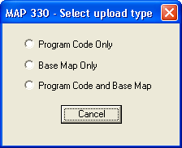

10- Select Upload File in the UPLOAD FILE window :

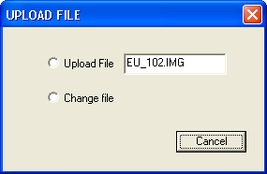

11- Uploading will start :

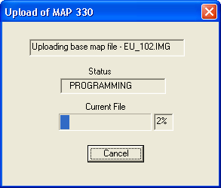

Loading time is about 15 mn. At the end of the load , the receiver will restart again , and PC displays :

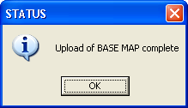
On the first screen of the receiver , you should have the firmware version (V2.10) and below the base map version (V1.02)

